Tru Cafe: Accessibility Overview  
1500 W 2nd Ave, Vancouver, BC V6J 5C5

# Signage

* **Visible at the front entrance**
* **No braille**

# Parking and Transit

* **Parking immediately next to the cafe, in the middle of a number of buisnesses**
* **Accesible parking?? (FILL THIS IN LATER)**

# Exterior

* **Main entrance is a push button activated, automatic door**
* **Curb along West 2nd Avenue**

**MISSING FRONT ENTRANCE IMAGE**

**Image Description: Outside door of Federation Gallery**

# Interior

**Image descriptions:**

**Image descriptions:**

# Lighting

# Stage/Backstage

# Seating

# Bathrooms

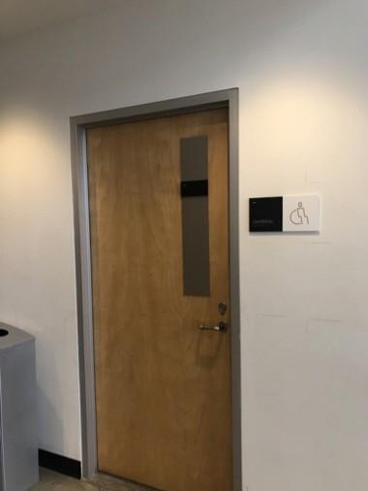 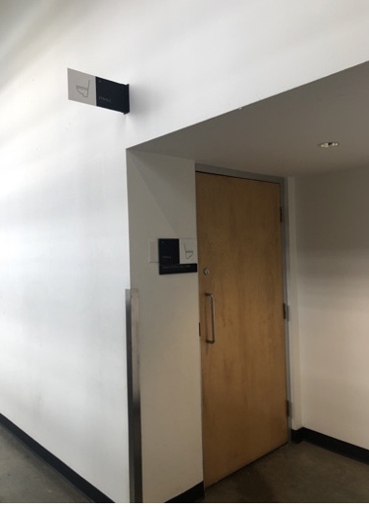 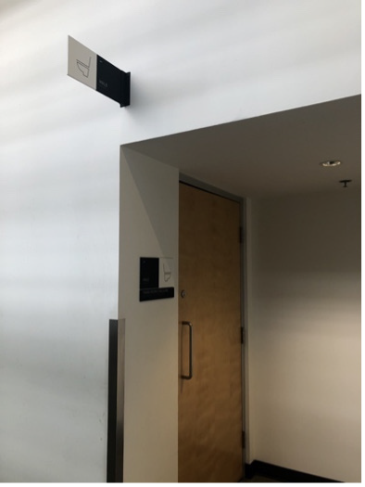

**Image descriptions:**

**Image number 1, mobility device accessible washroom (4th floor), seperate from other washrooms.**

**Image 2 & 3, gender neutral bathrooms with toilets.**

# Assistive Listening Arrangements

* + **4 Sennheiser-assisted listening devices**

# Guide Dogs

* + **Ask AU - Room for guide dogs at seat**
  + **Rest/toilet area for guide dogs outside of venue**